UROP ANNUAL REPORT 2007-08

University of Utah Undergraduate Research Opportunities Program

The University of Utah’s Undergraduate Research Opportunities Program (UROP) provides undergraduate students with the opportunity to work with faculty sponsors on original research or creative projects. In addition to helping students find faculty sponsors, the Program pays students an hourly wage amounting to $1200 for a first semester and $600 for a one-time renewal to work on their research. Students are accepted into the program on the basis of faculty-reviewed research/creative proposals. UROP also sponsors a number of venues for the dissemination of student research. These include an annual research symposium (required of all UROP students, but open to all students who have worked with a faculty sponsor) and a research abstracts journal serving undergraduate researchers campus-wide. Finally, the Office of the Vice President for Research, the Office of Government Relations, the Department of High Performance Computing, and UROP, along with Utah State University, participate in sending students to an annual symposium at the Capitol each January consisting of research posters.

During the past year, UROP has served 215 students, an increase of 49 students over the 2006-2007 academic year, and an increase of 108 students over the 2005-2006 academic year.

We have gained one new named assistantship this year, the Afton B. Bradshaw Assistantship in the Humanities, created and sustained by UROP Assistant Director Jill Baeder, to make a total of 6 named assistantships for undergraduate researchers:

• Bamberger Foundation Assistantships
(All disciplines accepted, 3 available)
• Tony Cummings Assistantship (Community based research, all disciplines accepted)
• Ann K. Volkman Health Sciences Assistantship (Highest scored academically reviewed proposal and application materials within the health sciences)
• Afton B. Bradshaw Assistantship in the Humanities ($2400 for a student selected by committee)

Recipients of Named Assistantships for 2007-2008

Brin Bon – Philosophy – Cummings Scholar
Jared Thorley – Nursing – Volkman Scholar
Tori Ballif – History – Bradshaw Scholar and Charles Monson Essay prize winner for 2008
Shontol Burkhalter and Deisy Ramirez Aguilar – Sociology - Bamberger Scholar – shared
Scotti Hill – Art History – Bamberger Scholar
Nicholas Augustus – Civil Engineering – Bamberger scholar

UROP contributed $1200.00 in supply funding for the named assistantships as this funding is not provided for in the donations.

The number of recipients of the Undergraduate Research Scholar designation continues to grow. For the 2007-08 academic year (including summer ’07) 98 students received the designation compared with 86 for the 2006-07 academic year (including summer ’06). This designation, which appears in the awards section of a student’s transcript upon graduation, can aid in enhancing graduate school applications as well as applications for employment.

Having hosted the Utah Conference on Undergraduate Research (UCUR) last year, UROP continued in an active role in planning and implementation , and took 14 student presenters to UVSC which hosted the conference this year.

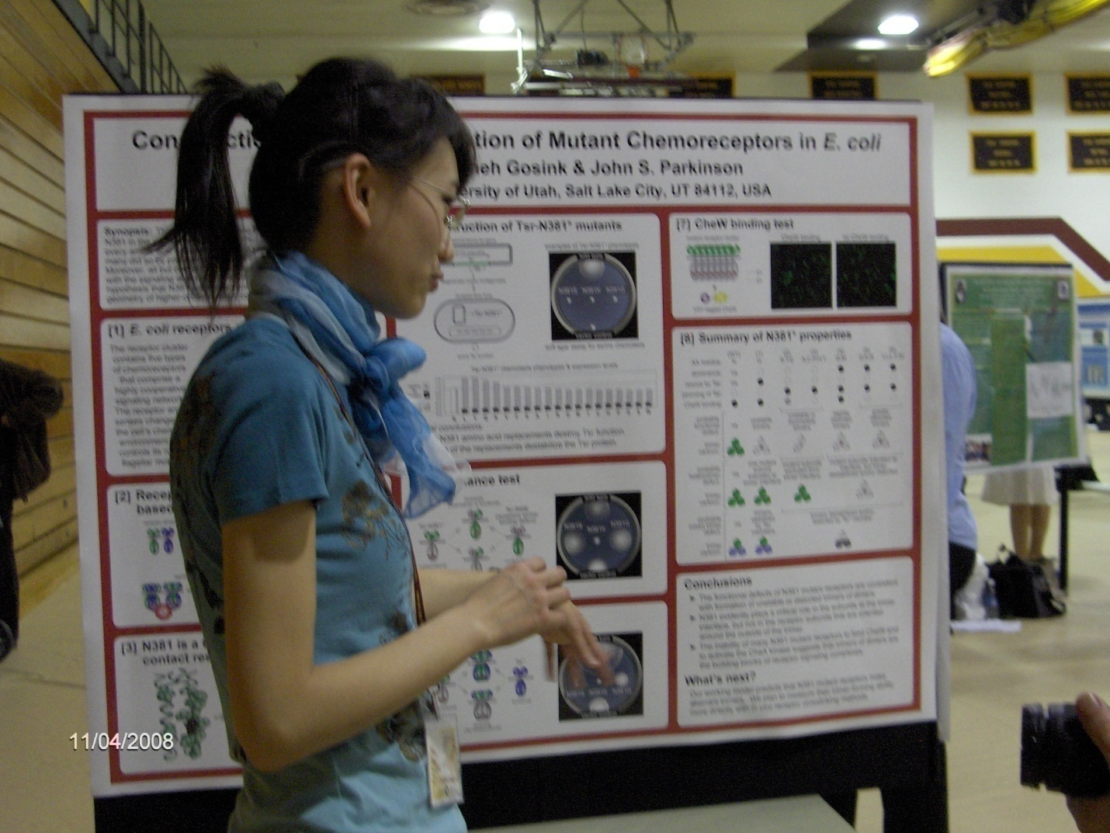

Yimin Zhao presenting her poster at UCUR

This year’s Research Posters on the Hill was again a great success and drew a significant number of legislators. The return to the newly refurbished capitol added excitement to the event. The University of Utah was represented by 27 students who presented outstanding posters.

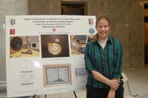

Jaimie Rankin with her poster at Research Posters on the Hill

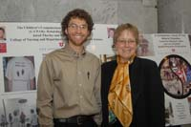

Volkman winner Jared Thorley with his faculty sponsor,
Patricia Pearce, at Research Posters on the Hill

The annual Undergraduate Research Symposium, sponsored by UROP and the Honors College, took place in the Olpin Union on April 3rd and consisted of over 130 poster and oral presentations including Honors Senior Thesis presentations. The Ruth Eleanor Bamberger and John Ernest Bamberger Memorial Foundation provide funding to defray the $5000 cost of the Symposium.

The Symposium was, again this year, the occasion for the announcement of the Charles Monson Essay Prize. This year’s Monson Prize went to Undergraduate Studies intern and UROP Bradshaw Scholar Tori Ballif.



Monson Essay Prize winner Tori Ballif at the 2008 Undergraduate Research Symposium

The Undergraduate Research Abstracts Journal continues its 8th year of publication with a small run of 1000 copies for students, faculty, the University community, trustees and the legislature. The journal is also digitized by the Marriott Library as part of its on-line journal program. This year the journal is comprised of 131 undergraduate abstracts reflecting research and creative work from all 10 colleges with many from the School of Medicine and Huntsman Cancer Institute. The Research Posters on the Hill section boasts 27 posters and abstracts from our session in January 2008. New this year, is a section featuring the Monson Prize. Award winner Tori Ballif was provided with several pages to feature her abstract, photographs and detailed information about the Monson Essay Prize. The Honors College submitted 18 senior thesis abstracts for the final section of the book (although this is a lower number than in previous years, changes have been put in place to insure that numbers will be back up to normal in future years) . We are also considering a fall edition perhaps on-line only to capture Honors College abstracts that come in later than our spring publication deadline.

Once again, we saw a significant increase in the number of students we took to the National Conference on Undergraduate Research (NCUR) from 16 at last year’s NCUR to 23 for this year’s which took place at Salisbury University (Maryland). UROP paid $175 for each NCUR student registration and coordinated the hotel and many of the travel arrangements.

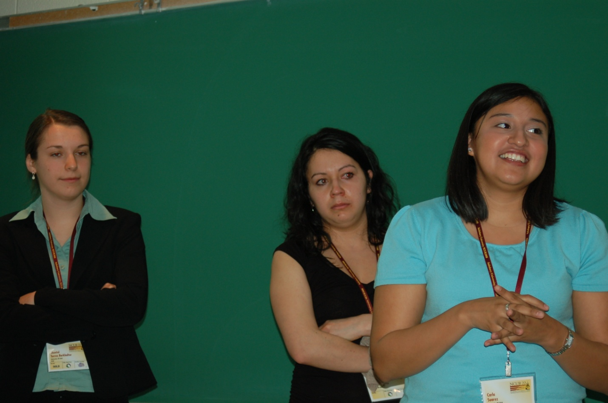

From left to right, Shontol Torres Burkhalter, Deisy Ramirez Aguilar, and Christina Suarez, presenting at NCUR

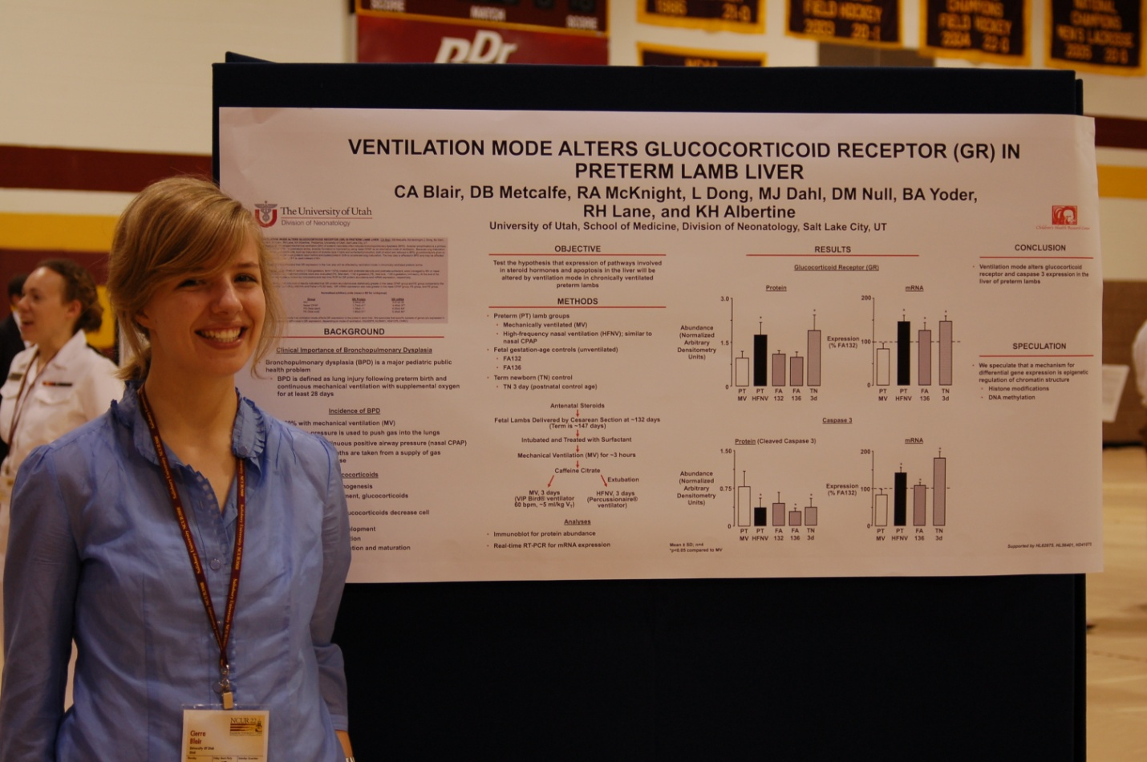

Cierra Blair with her research poster at NCUR

During June 2008 both the director and assistant director of UROP attended the Conference on Undergraduate Research (CUR) in St. Joseph Minnesota. This conference, which takes place every two years, provides invaluable sessions on all aspects of undergraduate research and many that focus on the role, funding and running of undergraduate research programs.

Changes Made

$50,000 was added to the UROP base budget this year, increasing the total base budget to $115,000. This, along with contributions from the Vice President for Research, enabled UROP to meet the costs of an increased student population.

An important change in the structure of UROP has seen the departure of the UROP designated intern who has been replaced by an administrative assistant/ receptionist position. The addition of Andrea Haag to our staff has enabled us to shift the task of payroll and payroll related duties away from the assistant director position freeing up Jill Baeder to work on the already more than full time duties of her position.

Last year an agreement was put into place with ARUP whereby they would fully fund up to five students who would work in labs at ARUP through UROP. This year, because of the enthusiasm generated by our students’ performance, ARUP increased the number of students it funds from 5 to 10. This arrangement benefits both the organization and the students. ARUP trains students who may later return to work there rather than seeking employment elsewhere and who, as regular employees, don’t need to be trained in ARUP’s procedures. Students receive the benefit of working with top researches in a medical research facility. We hope to expand this arrangement to additional companies in Research Park in the coming year, and to that end, have solicited and received introductions and testimonials from ARUP.

The Tony Cummings Assistantship has changed from its original focus to a new focus on community-based research. This new focus will help UROP to increase student interest in this vitally important area of research.

Through the implementation of the Undergraduate Research Scholar designation (URSD) as well as through increased efforts at publicity, once again, we have (as mentioned above), increased our student population, this time from 166 last year to 215 students this year.

The UROP web site will be upgraded during the summer of 2008. This site provides essential information to students, including application forms, deadlines, links to conference sites, and a directory of faculty sponsors by department and research interest.

Analysis and Appraisal: Assessment of Strengths and Weaknesses

We have continued to use the following assessment tools:
- Graded abstracts submitted by students as a final requirement for UGS 4800 (Undergraduate Research)
- On-line student evaluations for UGS 4800
- Survey of UROP participants by major
The above assessment tools indicate:
- Continued high performance on the part of students;
- Increased student satisfaction (the assessment from two years ago indicated dissatisfaction owing to lack of contact with the UROP Director who was being evaluated; for the past two years, as a result of the director’s presence and introductory remarks at fall, spring, and summer orientations, this situation seems to have been ameliorated).
- Continued success in our students’ applications and acceptances to graduate schools.
Beyond assessing student satisfaction and performance, informal assessment of the health of the program indicates that:

- The goal of expansion continues to progress well – (see above); the continued growth can be considered a strength as well as a recurring goal;
- The primary weakness continues to be adequate operating funds; expansion has put more stress than ever on our available resources and staff.

Recommendations/Actions

In response to the analysis of our strengths and weaknesses we have the following recommendations:

- Continue to use every opportunity to familiarize the campus with UROP and to involve the program in campus initiatives and events.

- Follow up on leads provided by ARUP in Research Park to try to establish more arrangements of the kind that we have with ARUP.
The following actions have been taken:

- Partnerships initiated with ARUP continue to increase the number of students we serve.

- The Senior Associate Vice President for Academic affairs in conjunction with the Senior Vice President for Academic Affairs have increased our base budget by $50,000 (as mentioned above) to $115,000. With this increase, and the extra funding we receive from the Vice President for Research and the Senior Vice President for Health Sciences, we will be able to operate with sufficient funding at our current level (additional expansion will, of course, require additional funding which we are pursuing as described above).

