Department of Communication
Five-Year Assessment
Fall 2020

This report summarizes actions taken in the Department of Communication from Fall 2018 to Fall 2020 to establish, implement, and assess expected learning outcomes (ELOs).

Mission of Department
The mission of the Department of Communication of the University of Utah is to enhance the practice and understanding of communication in its intellectual, professional, cultural, and environmental contexts.
We view communication as central to the integration and dissemination of information, the recognition and appreciation of diversity, and the development and application of technical and social knowledge. In communication scholarship, our department draws upon the full spectrum of methodologies and perspectives.
Through teaching, research, and service, the Department serves the needs of its students and contributes significantly to the University's commitment to educational development through the discovery, refinement, and exploration of knowledge.

Four Communication Emphases and Capstone Courses
In Fall 2018, the process was started to move the Department’s four sequences official emphases. This status was granted in Spring 2019. In that transition, a capstone requirement was added to each emphasis to address the University mandate to assess learning outcomes for each major. The capstone courses for each emphasis consist of the following:

- Communication Studies
  - COMM 5000 Studies in Communication
  - COMM 5370 Environmental Communication, Special Topics
  - COMM 5490 Communication and Social Justice
  - COMM 5640 Communication, Technology, and Culture
  - COMM 5815 Health Communication, Special Topics
  - COMM 5820 Science Communication, Special Topics
- Strategic Communication
  - COMM 5580 PR Cases and Campaigns
  - COMM 5490 Communication and Social Justice
  - COMM 5950 Advanced Special Topics in Strat Comm
- Journalism
  - COMM 5665 Social Media Journalism
  - COMM 5775 Voices of Utah
  - COMM 5850 Advanced Special Topics in Journalism
- Communicating Science, Health, Environment, and Risk (CommSHER)
  - COMM 5370 Environmental Communication, Special Topics
  - COMM 5815 Health Communication, Special Topics
  - COMM 5820 Science Communication, Special Topics

Department of Communication Expected Learning Outcomes

In Spring 2019, the Department of Communication adopted five ELOs and developed an assessment plan to gauge how well students are meeting these objectives. The five ELOs used to assess the BA and BS degrees for all four emphases are as follows:

- Demonstrates relevant communication skills which must include writing, but not exclusively. Basic communication skills include:
    - An argument supported by appropriate evidence.
    - Writing conventions specific to the context.
- Demonstrates upper-division knowledge of concepts and skills specific to the emphasis (i.e. Journalism, Strategic Communication, Communication Studies, Communicating Science, Health, Environment and Risk).
- Engages issues of difference and identity (e.g. gender, race, ethnicity, nationality, sexuality, ability, and/or age).
- Demonstrates social, historical, legal, environmental, and/or economic context of the topic or project.
- Engages ethical parameters of the topic or project.

Evidence to Assess Learning Outcomes
Individual faculty members who teach a capstone course will design an assignment - a paper or project - that should address the above five outcomes. Faculty will link that assignment to the “Associator” feature in Canvas. A randomized sample of 20% of assignments associated with each outcome will then be assessed for evidence of the learning outcomes.

Plan to Assess Learning Outcomes
Every 2 years – academic years that begin with an odd number – two learning outcomes will be identified and assessed in capstone courses taught in that academic year.

The Department of Communication Undergraduate Committee will use the Outcome Coordinator to review the artifacts collected from each course. After reviewing the artifacts, the committee will meet to discuss the results which will include a quantitative analysis provided by the Outcome Coordinator, as well as qualitative comments about the review process and artifacts. Based on this discussion, it will be determined what actions should be taken. Potential actions range from revising learning outcomes and rubrics, to recommended changes in the curriculum. Based on this discussion, a report will be written by the Director of Undergraduate Studies, approved by the Undergraduate Committee, and then passed onto the Department Chair. If curricular changes are recommended, those changes will be discussed and voted on by the full faculty.

In addition to reviewing learning outcomes assessed in past courses, the Undergraduate Committee will determine what new learning outcomes - usually two - will be assessed in the next review cycle.

Rubrics for Outcomes
For capstone courses taught in Fall 2019, two ELOs were selected for assessment:

  - Demonstrates relevant communication skills which must include writing, but not exclusively. Basic communication skills include:
    - An argument supported by appropriate evidence.
    - Writing conventions specific to the context.
  - Engages ethical parameters of the topic or project.

The following rubrics were developed for each ELO.

Learning Outcome and Rubrics
Demonstrates relevant communication skills which must include writing, but not exclusively. Basic communication skills include:
- An argument supported by appropriate evidence.
- Writing conventions specific to the context.

An argument supported by appropriate evidence.
No Evidence No argument.
Developing Inarticulate Argument and/or no data.
Accomplished Argument with no, or insufficient data.
Exemplary Clearly Articulated argument and appropriate data.

Writing Conventions
Yes
No

Learning Outcome & Rubric
Engages ethical parameters of the topic or project.

No Evidence Lacks consideration of ethical parameters.
Developing Superficially addresses ethics in name, but not in substance.
Accomplished Addresses complexity and nuance of ethical parameters, but not well-applied
to the topic.
Exemplary Integrated use of well-supported ethical perspectives.

Assessment Results
In Fall 2020, the Undergraduate Committee, consisting of five members, assessed the two selected ELOs from capstone courses taught Fall 2019: COMM 5000 Critical Approaches to Film, Media, and Culture, and COMM 5580 Public Relations Cases and Campaigns. The committee concluded that the classes are meeting the learning outcomes, though they felt that some structural changes could be made to improve the learning experience.

Graphs with reviewer averages can be seen for each ELO.

Demonstrates relevant communication skills which must include writing, but not exclusively. Basic communication skills include an argument supported by appropriate evidence.
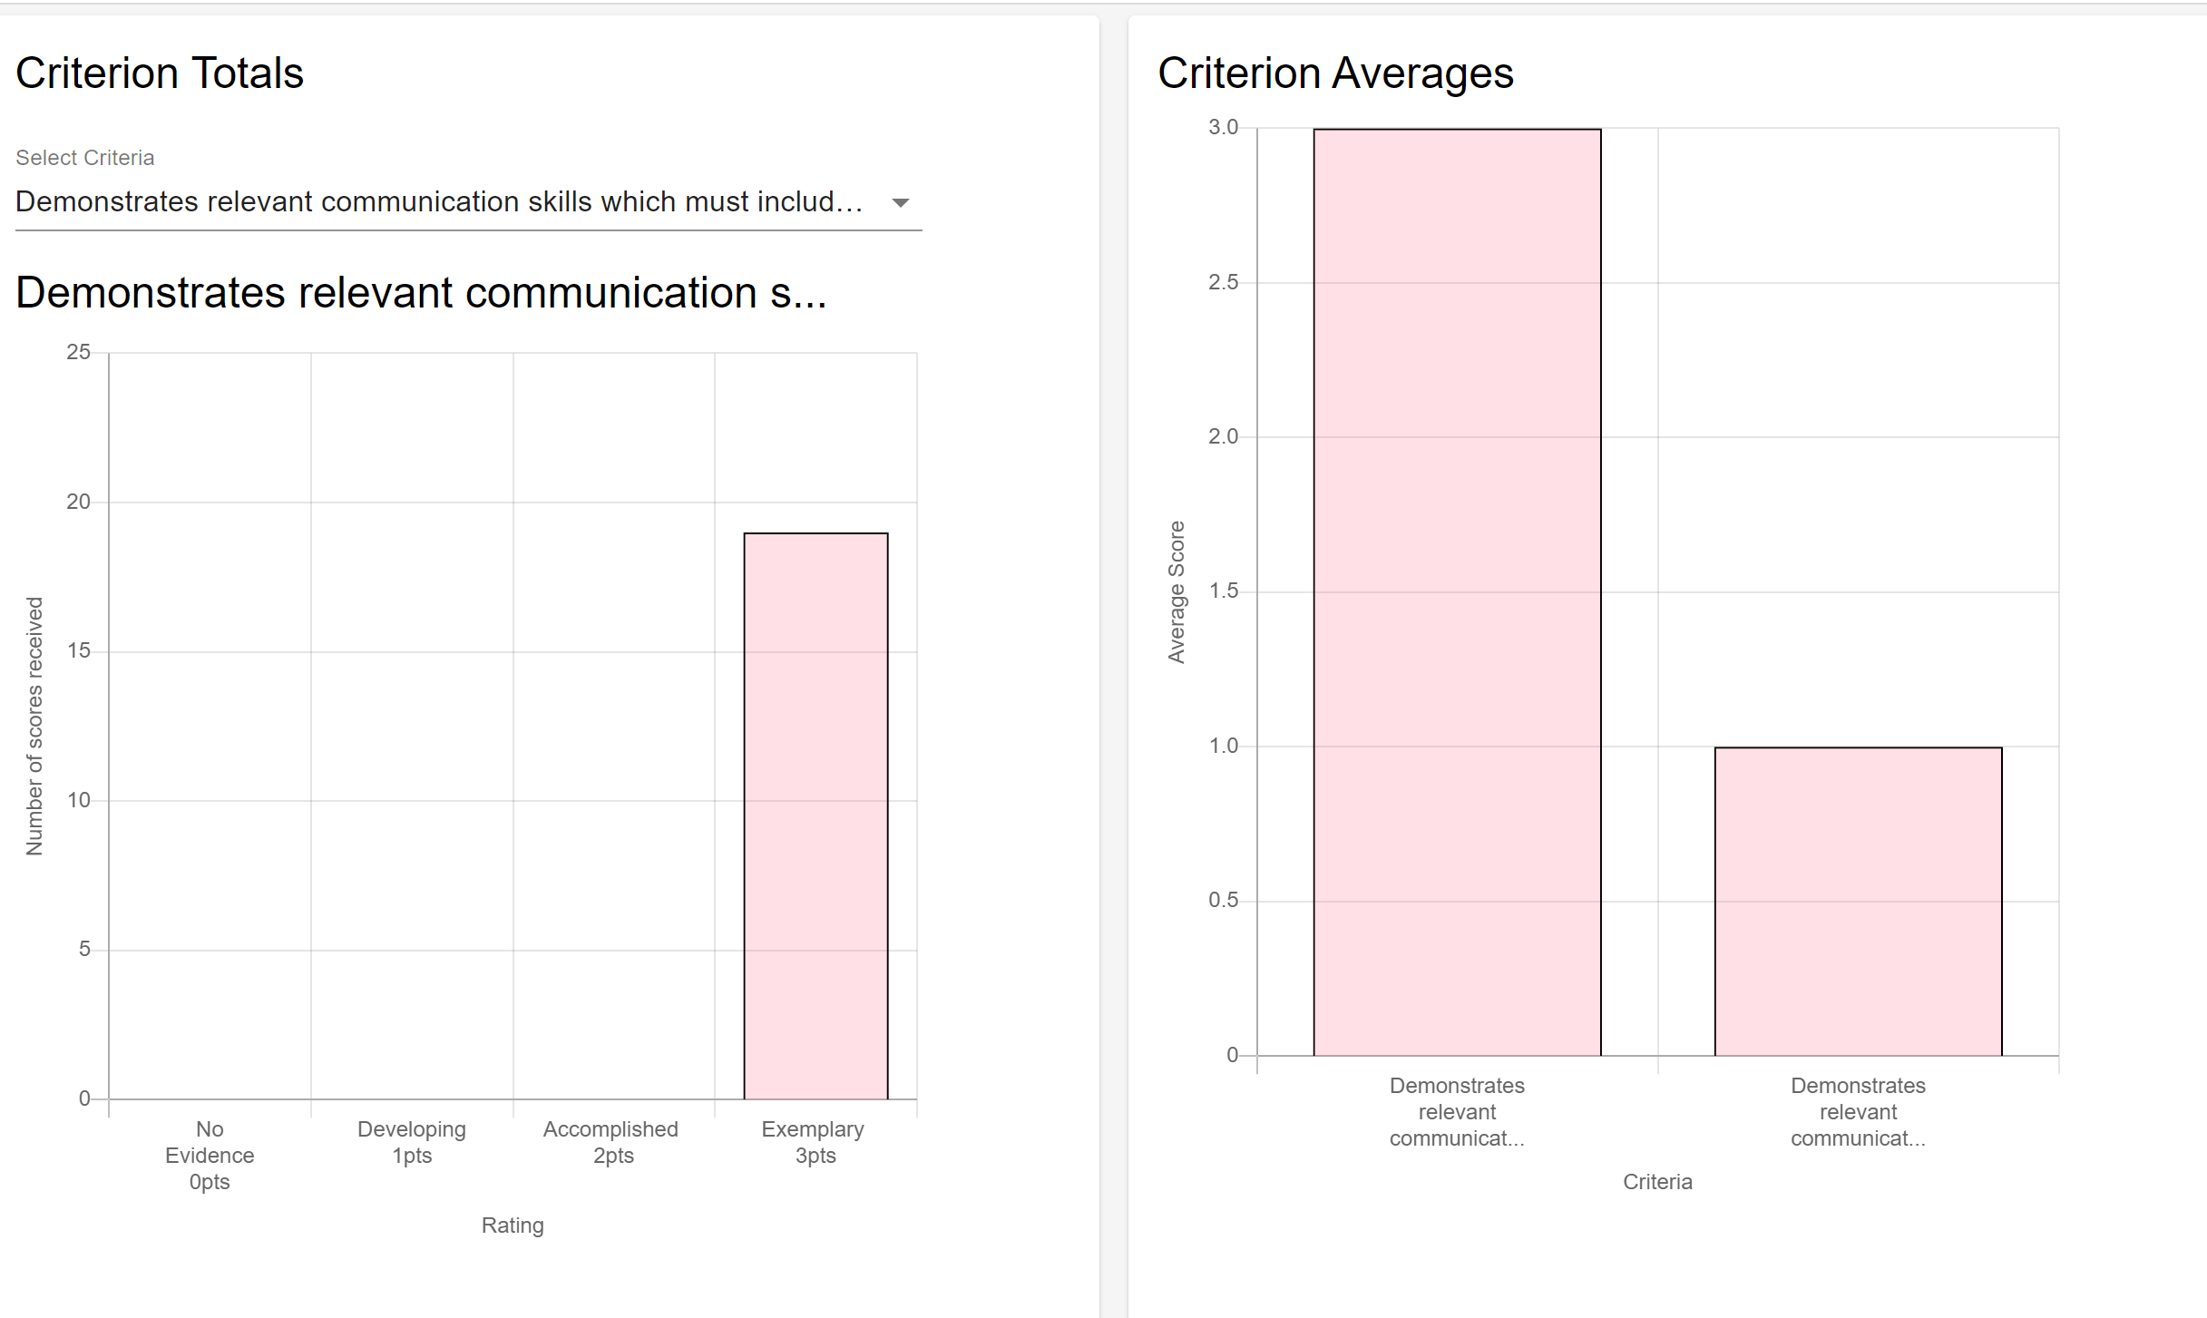
Demonstrates relevant communication skills which must include writing, but not exclusively. Basic communication skills include writing conventions specific to the context.
Engages ethical parameters of the topic or project.

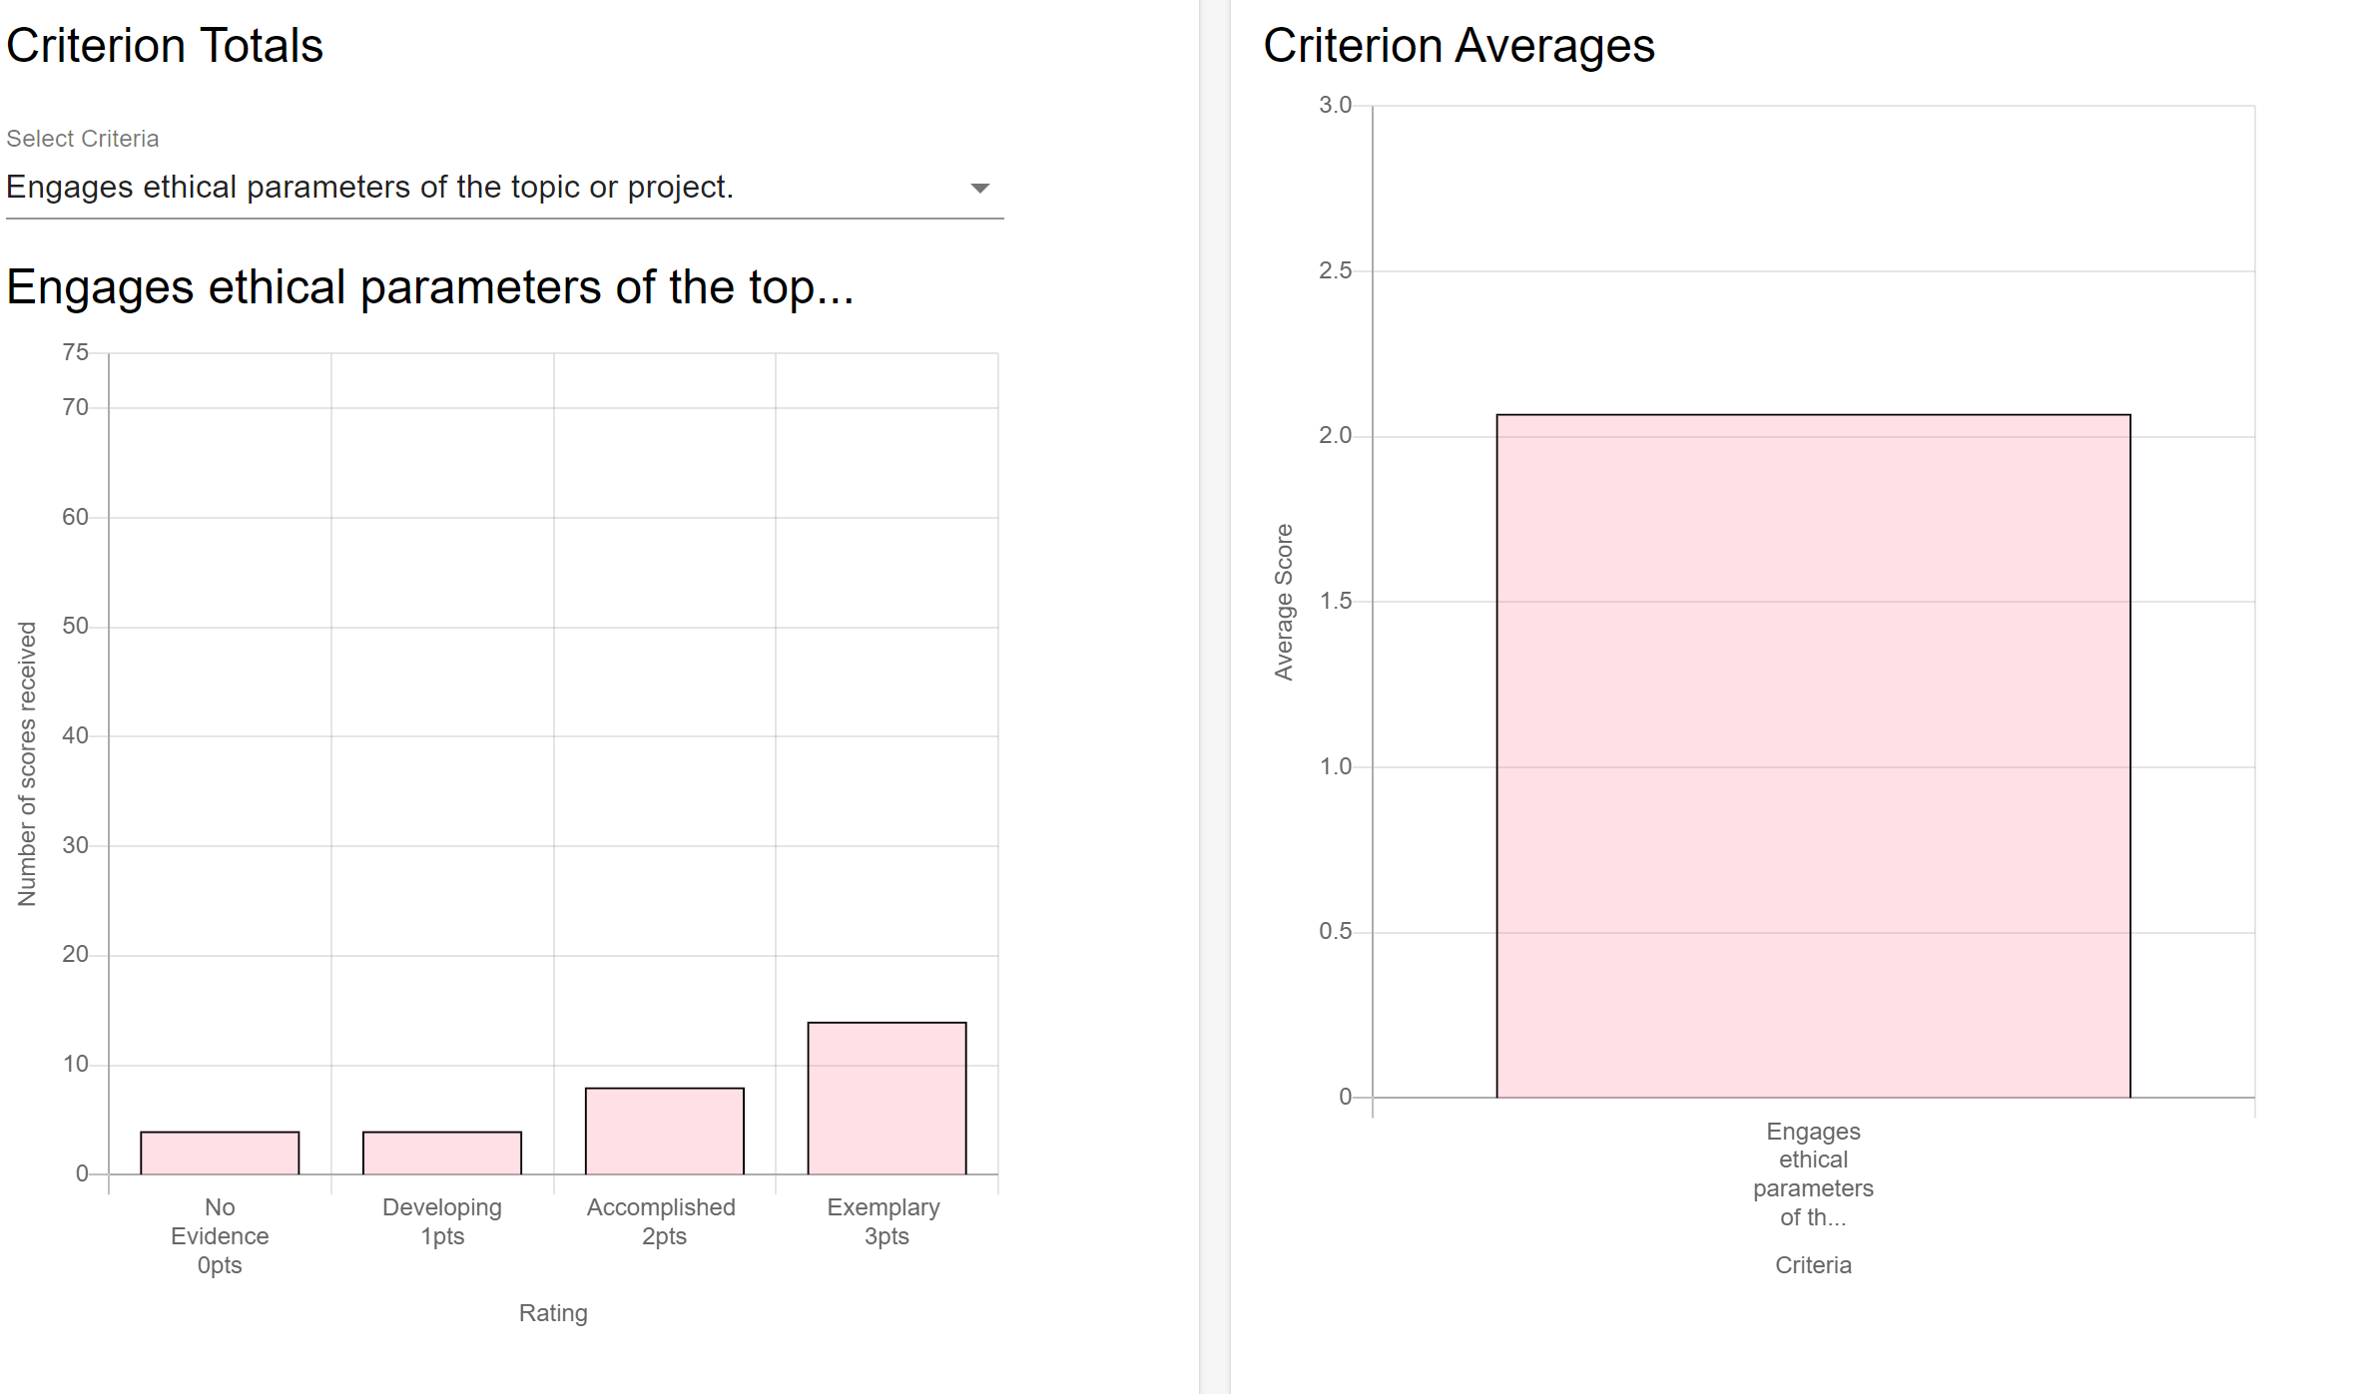

Recommended Changes
As mentioned, the Undergraduate Committee felt courses were meeting the selected ELOs but did recommend structural changes that will impact other ELOs assessed in future years. To address these concerns, the committee recommended four things.

- Require substantive assignments to assess each ELO. While one capstone course used a final paper to assess both ELOs, another class used a final project for one ELO and a short response – a paragraph in length – to assess another ELO. The committee found that paragraph-long responses lacked depth and resulted in a superficial review. As a result, the committee recommends that all assignments linked to outcomes be a minimum of 500 words in length.

- Establish prerequisites for capstone courses. Given the size and complexity of orchestrating course offerings for close to 1,000 students in four different emphases, the department has been judicious in not requiring too many prerequisites. The major concerns with having too many prerequisites are that they will hinder a student’s progress in the major and delay graduation. However, capstone courses are intended to be a culminating experience taken in a student’s last year and should provide an opportunity for reflection and synthesis as students complete significant papers and projects. In the review of artifacts from the 2019 capstone courses, it was clear that some papers and projects were written by students with a more advanced knowledge of the field and the relevant issues and theories. In a review of the composition of the students in the capstone courses reviewed, it was found that 30% of all students enrolled in capstone courses were juniors and 70% were seniors. In current capstone courses, non-senior students comprise 10%-38% of the course.
This gap in knowledge of the field can be challenging for instructors and will impact the future assessment of the ELO which expects students to demonstrate “upper-division knowledge of concepts and skills specific to the emphasis.” Ideally, the capstone course for each emphasis would have a prerequisite of a foundational, junior-level course. The committee was reticent to implement such a change as it would likely result in being a roadblock to graduation, especially in our current context of having a limited faculty. Already, the department struggles with a high student-to-faculty ratio which results in bottlenecks of certain course offerings that can delay graduation. To add a prerequisite, even if it would improve the learning experience for students, does not seem prudent at this time.
As a result, the committee recommended a softer prerequisite for all capstone courses which would require that students complete a minimum of 60 credit hours, or the completion of a Communication/Writing (CW) requirement. The department’s advising team was consulted to determine if this prerequisite would be a significant roadblock for students’ progress to graduation and the advisors assessed that is would not be a major impediment.
- Reduce bottlenecks in the Strategic Communication emphasis. The Strategic Communication emphasis is the largest in the department with about 67% of all Communication majors pursuing this emphasis. Unfortunately, there are very few faculty whose expertise falls in this area which results in those few faculty teaching capstone courses every semester. However, even with this handful of faculty dedicating themselves to these courses, the department is still unable to meet student demands. To not impede a student’s progress to graduation, accommodations have been made where students are permitted to take capstone courses in other emphases that have an indirect focus on strategic communication. This lack of course offerings in Strategic Communication is amplified further if a faculty member in that area is on leave.
The hiring of a career-line faculty member in Strategic Communication has long been discussed and supported by the faculty but has yet to occur. The Undergraduate Committee recommends that hires be made in the Strategic Communication area so that the needs of our undergraduates can be better met.
- Reduce course caps for capstone courses. As mentioned, the Department already struggles with a high student-to-faculty ratio. While capstone courses within the Journalism emphasis enroll no more than 20 students, in all other emphases the capstone courses are capped at, and consistently enroll, 36 students. This large course size impacts the level of student attention demanded for a meaningful and substantive capstone experience. While the Undergraduate Committee recognizes that little can be done at the current moment to address these large courses sizes, they do encourage the department to be mindful of future hires and how to establish more equity amongst course sizes.

In addition to working with the Undergraduate Committee, the Director of Undergraduate Studies obtained feedback from faculty who taught capstone courses and from the Department’s academic advisors. Their feedback involved some of the issues already addressed by the committee, but they also had additional recommendations:
- Reduce course caps so the focus can be on meaningful projects that provide students with in-depth mentorship.
- Require prerequisite to ensure all students have the skills to be successful when approaching a complex project or issue. Faculty recommended junior-level emphasis requirements of specific courses like COMM 4590 for Strategic Communication, COMM 3710 for Communicating Science, Health, and Environment, COMM 3555 for Journalism, and COMM 3030 for Communication Studies.
- Require an exit survey for graduating seniors that can be assessed by the advisors and the Undergraduate Committee. Since students are no longer required to meet with advisors to file for graduation, the Department lacks a means to conduct an exit interview as they did in the past. Requiring a survey would help bridge this gap.
- Provide a resource guide for faculty on the Department’s Canvas page regarding capstone expectations, ELOs, rubrics for assessing ELOs, a link/template for an exit survey, and a guide for how to navigate the Associator on Canvas.

Future Plans
ELOs. The Undergraduate Committee identified two ELOs for assessment in all capstone courses taught in the 2021-2022 academic year:
- Engages issues of difference and identity (e.g. gender, race, ethnicity, nationality, sexuality, ability, and/or age).
- Demonstrates social, historical, legal, environmental, and/or economic context of the topic or project.

Rubrics. In Spring 2021the Undergraduate Committee will develop rubrics to assess the above learning outcomes.
Prerequisites. Starting Summer 2021 all capstone courses will require that students complete a minimum of 60 hours, or a CW requirement.
Resource Guide. In Spring 2021 the Director of Undergraduate Studies will create a resource guide for all instructors of capstone courses which will include all ELOs, the specific ELOs that have been or will be assessed, rubrics the Undergraduate Committee will use to assess ELOs, expectations of assignments associated with ELOs, a link/template for an exit survey, and guide for how to associate different assignments with ELOs using the Associator in Canvas.

