Assessment of Learning Outcomes Program – Department of Geography
Fall 2017-Spring 2018

The program has four program learning outcomes that are tested for in the assessment program. These are:

- Basic understanding of the scientific discovery process in the discipline of geography.
Assessment is conducted in GEOG 3270/5270 Biogeography. GEOG 3400/5400 Population Geography and GEOG 3210/5210 Global Climate Change. These are upper division content courses which all geography students must take one or the other.

- Basic understanding of one geography subfield.
Assessment is conducted in GEOG 3270/5270 Biogeography (for physical geography students) or GEOG 3400/5400 Population Geography (for human geography students). These are upper division content courses which all geography students must take one or the other.

- Ability to think spatially and conduct basic spatial analysis.
Assessment is conducted in GEOG 3020 Geographical Analysis.

- Ability to critically understand knowledge communicated in written and cartographic forms.
Assessment is conducted in GEOG 3270/5270 Biogeography or GEOG 3400/5400 Population Geography, which are writing intensive courses, and Cartography GEOG 3040 .

The assessments are conducted in the final weeks of each class. The students are given a test of multiple choice and short answer questions using CANVAS. These questions, which were developed by the instructors, the Chair and the Undergraduate Committee, are standardized for each section and term of the course. Students are given credit to complete this test. Each instructor creates a brief report submitted to the Director of Undergraduate Programs that states the course, semester, number of students completing the test, the scores on the various questions and the average score for the all respondents

Overview of the results of the process for Fall 2017- Spring18

Geographical Analysis GEOG 3020 Spring 2018

During the last week of the Spring 2018 semester, the end of April, an assessment was conducted in GEOG 3020 as part of the Department of Geography’s evaluation of department wide Expected Learning Outcomes. The assessment for GEOG 3020 consisted of 8 multiple choice questions administered through the Canvas learning management system. A small amount of extra credit was offered for completing the exercise, which helped secure participation from 43 of 46 students, or 93% of the class. The number and percentage of students answering each question correctly was as follows:
Question 1, 30/43 = 70%
Question 2, 42/43 = 98%
Question 3, 39/43 = 91%
Question 4, 42/43 = 98%
Question 5, 41/43 = 95%
Question 6, 28/43 = 65%
Question 7, 24/43 = 56%
Question 8, 41/43 = 95%
It is worth noting that the average score was 83%, a 5% decrease from Spring 2017, but very similar to the Spring 2016 average score of 84%.
______________________________________

Global Climate Change GEOG 3210/5210 Spring 2018

Assessment administered April 24, 2018 via CANVAS Quiz function. The quiz consisted of five multiple choice questions. Seventy-one students ( 106 enrolled) completed the test questions. Overall class average was 76% (high score 100%; low score 40%).
Comments: Question #3 would have an acceptable answer with response B in most classes, although I spend a great deal of time on the importance of publication as a means of testing hypotheses. If choice B or D were allowed, class response rate would change to 96% answering correctly.

Principles of Cartography GEOG 3040 Fall 2017

The test consists of seven multiple choice questions and four problem solving exercises. The number of students who answered all questions was 47. The average of all of the correct responses was 92%.

Item Number | Number of Responses | Number of Correct Answers | Rate (%)
Multiple Choice # 1 | 47 | 41 | 0.872340426
Multiple Choice # 2 | 47 | 40 | 0.85106383
Multiple Choice # 3 | 48 | 45 | 0.9375
Multiple Choice # 4 | 48 | 43 | 0.895833333
Multiple Choice # 5 | 48 | 44 | 0.916666667
Multiple Choice # 6 | 48 | 44 | 0.916666667
Multiple Choice # 7 | 48 | 48 | 1
Problem Solving # 1 | 48 | 48 | 1
Problem Solving # 2 | 48 | 42 | 0.875
Problem Solving # 3 | 48 | 44 | 0.916666667
Problem Solving # 4 | 48 | 45 | 0.9375
______________________________

Population Geography GEOG 3400 Fall 2017

The learning outcomes test was available to students in Canvas for one week from 4 December, 2017 – 11 December, 2017. Students completed a ten-question quiz covering topics from all three units of the course (Fertility, Mortality, and Migration). Nineteen out of 21 students completed the Learning Outcomes assignment. The assessment questions are enumerated below. The correct answer appears in bold text. The general area of the assessment for course material is underlined. The percentage of students who answered each question correctly is in bold text in parentheses just before the text of the question. The average test score for the class was 64% (highest score = 100%, lowest score =30%). Students spent just over 7 minutes taking the quiz. Some of the questions might be too difficult, but low scores for particular concepts indicate the need to reiterate and emphasize their importance in this class in the future. In terms of implementation, the Learning Outcomes test went smoothly. Since this course was not evaluated and elaborated on last year, the detailed test information is provided below.
Understanding of the scientific discovery process in the discipline of geography
- (16%) A census is an important data resource that is used by population geographers to understand populations. These data are classified as:
- Primary
- Secondary
- Tertiary
- Longitudinal

- (89%) Which of the following is NOT a measurement used in the ‘basic population geography formula’ that estimates the population of a region?
a) Births (eg. Total Fertility Rate)
b) Stage of Epidemiological transition (eg. early or late).
c) Deaths (eg. Crude Death Rate)
d) Migration (eg. Net Migration)

- (26%) Due to _____________________ , a population geographer may reach different conclusions about education, health, or employment for states or counties than for an entire country when conducting statistical analysis.
- Cartography
- Hierarchical scale (level)
- Exponential population growth
- Per capita metrics

Basic understanding of at least one geographic subfield
- (63%) Total Fertility Rate is an aggregate statistic predicting:
a) The time that it takes for the population in a given region to double
b) The expected number of children that a women would have based on the age-specific fertility rate during a given year
c) The number of live births within a population per 1,000 women
d) The number of women of child-bearing age who achieve their desired family size

- (42%) Replacement level Total Fertility Rate is:
a) Always 2.1 children per woman
b) Influenced only by biology
c) Dependent on standard of living and social context
d) Only achieved in industrialized countries

- (95%) According to demographic transition theory, natural population decline within a country or society will take place:
a) In stage one, where birth rates and death rates are both high
b) In stage five, IF migration into that area does not take place
c) Population size will never decline because population grows exponentially
d) Where poverty is common

- (74%) Garret Hardin, author of the 1969 ‘tragedy of the commons’ article in Science, argued that population growth and the demand for food worldwide would outpace natural resource capacity. Whose comprehensive arguments against Hardin’s position won the Nobel Prize in 2007?
a) Thomas Malthus
b) Paul Ehrlich
c) Emmanuel Wallerstein
d) Elinor Ostrom

Ability to critically understand knowledge communicated in written and cartographic forms
- (47%) The population pyramid shown below is characterized as

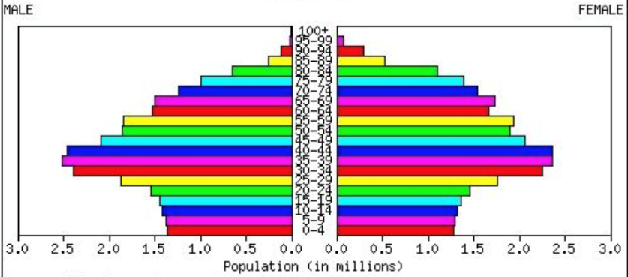
a) Regressive
b) Stationary
c) Progressive
d) Elongated

- (95%) A graphical representation of the migration ‘gravity model’ shows:
a) The relatively small number of population centers in mountainous rural regions
b) Pathways of migration among cities as a function of distance between them and their population sizes
c) The substantial recent growth of informal settlements/slums in the developing world
d) That the likelihood of permanent migration is a function of age

- (95%) Country-by-country, global maps of fertility (eg. Crude Birth Rate) and mortality (eg. Crude Death Rate) reveal:
a) Divergent patterns where fertility is low in regions with high mortality
b) High fertility in wealthy countries where families can afford more children and live longer
c) General overlap between high fertility and high mortality in developing countries
d) Powerful effects of climate region

Summary

Overall, the program assessment process is successful. The percentage of students correctly answering the questions is in the 80-90% range. Instructors and the Undergraduate Committee are learning from the process. The responses to specific questions within each course is being reviewed by instructors, especially on those questions with lowered correct responses. The instructors will evaluate whether they are covering this material sufficiently. In a broader sense, the Chair and the Undergraduate Committee will evaluate the questions and the outcomes they service to determine if changes are needed.

