6/29/21
Spark Program Summary

Mission:
The Spark Innovation Lab is dedicated to investigate difficult challenges within the undergraduate experience and generate innovative solutions. Utilizing a trans-disciplinary cadre of students and a design thinking approach, the lab endeavors to make lasting change with the student voice at the center of its effort.

Method:
Spark uses a human centered approach enabling talented students to creatively design real solutions for the University of Utah undergraduate experience. Students from all disciplines who are passionate about student experience are encouraged to lend their unique skills to Spark projects. Spark teams are made up of a cross section of University students in order to take the best from each discipline and match it to needs of the particular issue. Students involved in the Lab learn a process based on identifying, communicating, and addressing real needs in an educational setting. The projects are built on University administration goals. Each project extensively focuses on context, research methods, and implementation as part of the entire design thinking process. The resulting study is a culmination of research leading to human centered solutions.
In addition to guidance from University administrators, the Spark Lab Fellows provides student participants the tools to gain an in-depth understanding of the problem-solving process. Students who choose this opportunity take on leadership roles and receive impressive experience that differentiates them. A welcome package that we use can be downloaded here.

The systematic process that the Lab utilizes is grounded in Design Thinking. The 5 stages of the process are Observe, Analyze, Ideate, Prototype and Implement.

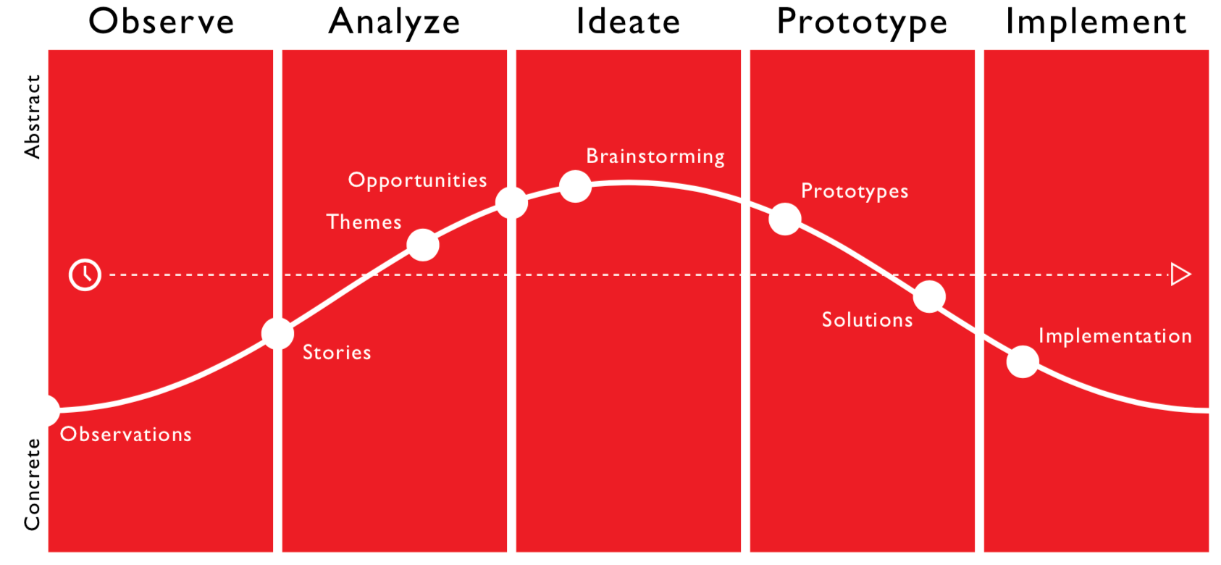

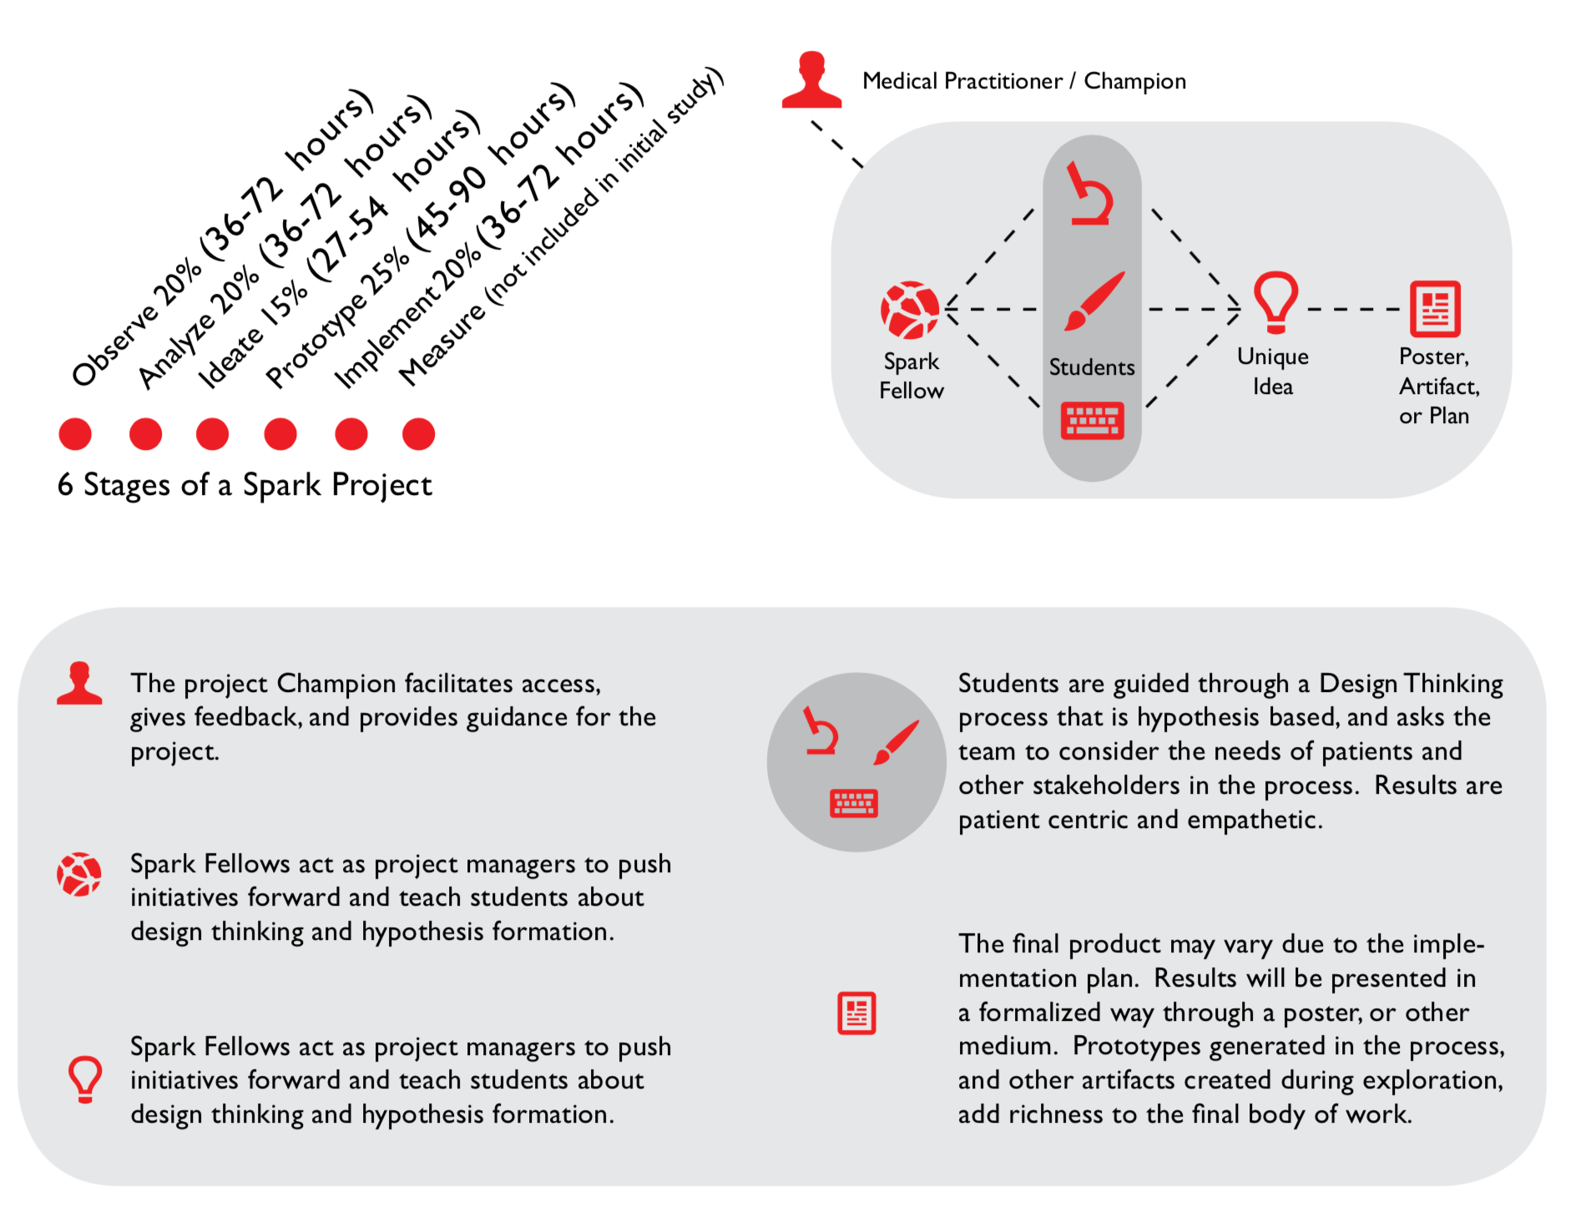
Champion

In addition, the students associated with the Lab will establish a Student Advisory Panel that will be available to provide structured feedback on efforts associated with the Undergraduate Experience at the University of Utah.

Structure:
The Spark Education Lab is directed by the Faculty director, supported by the Student director and then assisted in the individual projects by Lab Fellows. Each Fellow can supervise at least three projects. Lab Fellows then work with student volunteers on projects. Each student team is made up of 3 – 5 students who will work for one or two semesters on a project.

2020 – 21 Student Activities

During the 2020-2021 academic year, we had approximately 9 students working on a variety of projects.

Orientation:
We had 4 students working on issues around orientation prior to and after COVID. They created a new structure for all in person material that is being prepared by Adobe. In addition, they created a new structure and material for online orientation. These students were invaluable at providing orientation a structured and sequenced approach for online orientation that was very student centric. I imagine that students will continue to work with the Orientation team and help strategize how best to move back in person and coordinate information that is given to students.

General Education:
We had 2 students working with us on General Education structure and communication strategies. These students help ensure that what we were doing was student centric and that our messaging and structure was understandable and related to students.

Digital Student Experience:
Due to the shift to all online instruction and administrative functions, we had a group of 3 students research the digital experience for students and give recommendations from their perspective. This culminated in a report that can be downloaded here or a short version here. This presentation was given by the students to a variety of academic leaders for their consideration.

Degree Dashboard/DARS interface development:
The degree audit is utilized by the University of Utah as a tool to enter, maintain, enforce and display rules and status for student degree completion. However, the degree audit visualization is extremely outdated and difficult for the student use. This was brought up by the students in their digital experience work and is under the purview of UGS. 3 students worked on this project and it will be complete by August 1st with final recommendations. Here is the current report.

Administrative Activities

From an administrative perspective, the program is stable and effective. We have a good recruitment strategy to have a diverse group of students participate. They have been very engaged and are contributing greatly.

For the next year, we will work on program assessment, and also issues regarding the student experience around equity and inclusion.

COVID-19 Response

In response to the COVID-19 crisis we had to make some minimal adjustments to our work and just moved all meetings to Zoom. There was a bit of disruption of work due to some budget concerns but it did not reduce the students effectiveness.

Goals

We will continue to work on projects and many of the students that worked with us in the past will continue working these next semesters. A major focus will be on equity and inclusion work, major maps, and assessment communication. We have already made good headway in this direction.

Budget

We have requested $30,000 for the 2021-2022 fiscal year with the assumption that amount could be increased by 2.5% based upon the budget discussions and decisions.

